Test Your Knowledge: Quiz

1. What are the main functional differences between a while and a for?

- A while keeps looping until a condition is False. Normally you don't know how long it will take

- A for iterates through the items in any ordered sequence or other iterative object. Normally, the number of iterations is known.

2. What’s the difference between break and continue?

- break: Jumps out of the closest enclosing loop (past the entire loop statement)

- continue: Jumps to the top of the closest enclosing loop (to the loop’s header line)

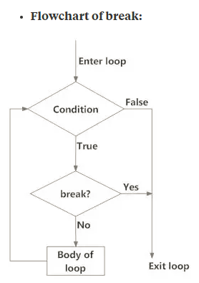 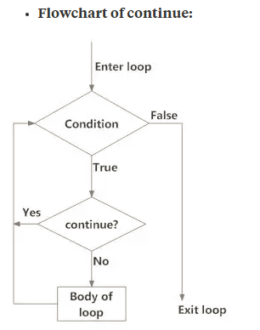

3. When is a loop’s else clause executed?

The else clause executes when the loop completes normally without encountering any break

4. How can you code a counter-based loop in Python?

Using range or counting variable, ..

5. What can a range be used for in a for loop?range(stop) range(start,stop) range(start,stop,step)

Stop, start, step: must be integers, positive or negative